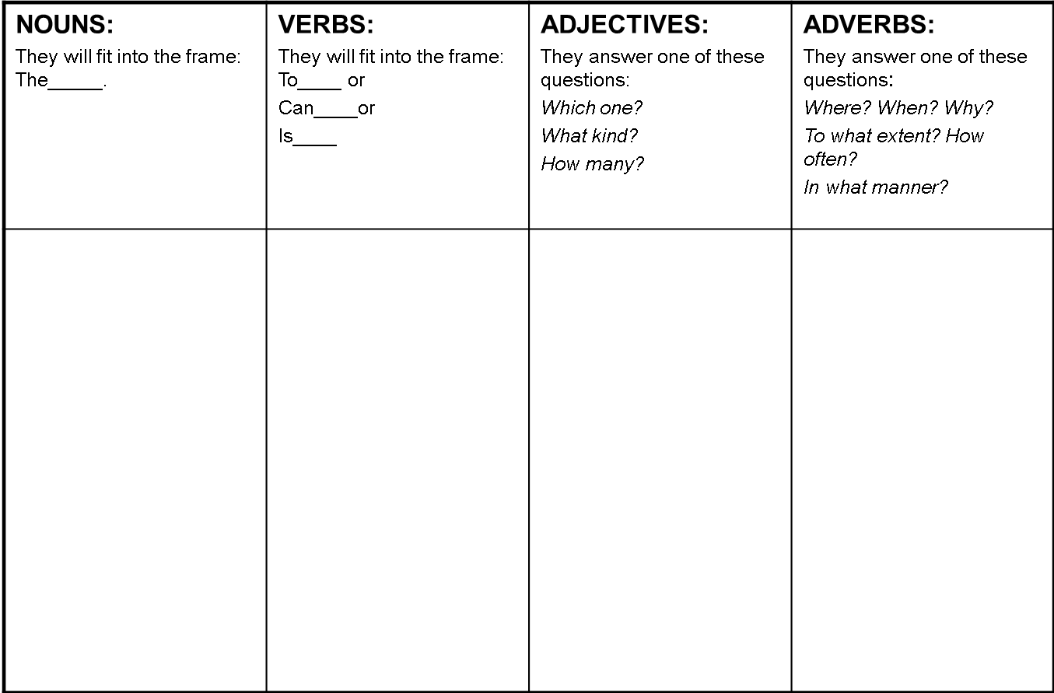

psychology

conscious

unconscious

motivation

Content Vocabulary: “Flowers for Algernon”

Please complete the following “morphology” chart, as well as the attached Frayer models forthe following five vocabulary words.

**motivation unconscious conscious psychology**

Word

Word

Word

Word

Use the word in a sentence.

Use the word in a sentence.

Use the word in a sentence.

Use the word in a sentence.

Visual

Aid

Visual

Aid

Visual

Aid

Visual

Aid

Part of Speech

Part of Speech

Part of Speech

Part of Speech

Synonyms

Synonyms

Synonyms

Synonyms

Definition

Definition

Definition

Definition

Word

Use the word in a sentence.

Visual

Aid

Part of Speech

Synonyms

Definition